INCREMENT_A
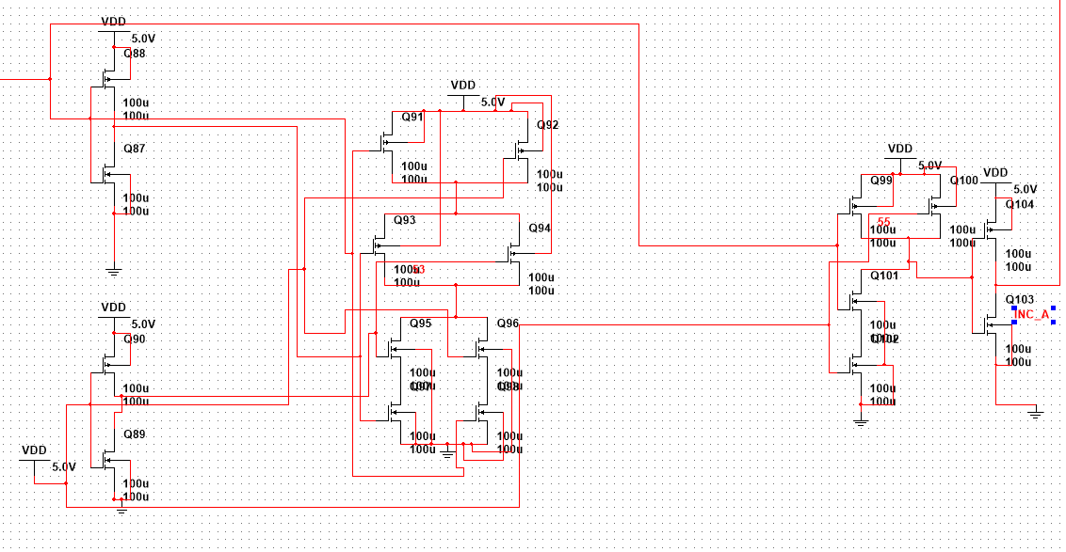
HERE WE ARE TAKING CARRY AS OUTPUT
IF INPUT_A=1, CARRY =5V(LOGIC 1)
THEN OUR DESERVED OUTPUT IS 10 (2)
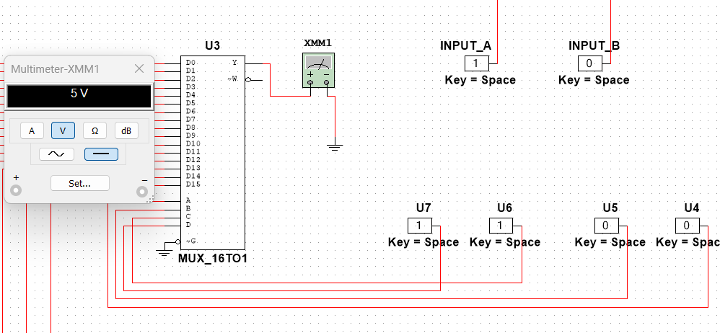
IF INPUT_A=0 ,CARRY =0V(LOGIC 0)
THEN OUR DESERVED OUTPUT IS 1 (1)

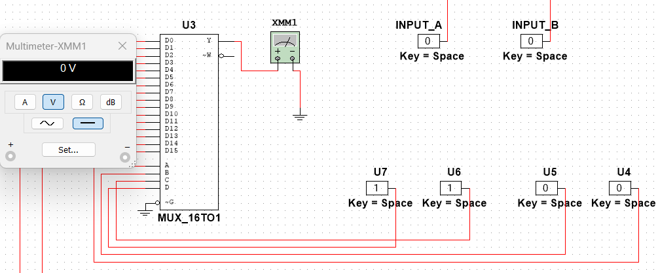

INCREMENT_B

HERE WE ARE TAKING CARRY AS OUTPUT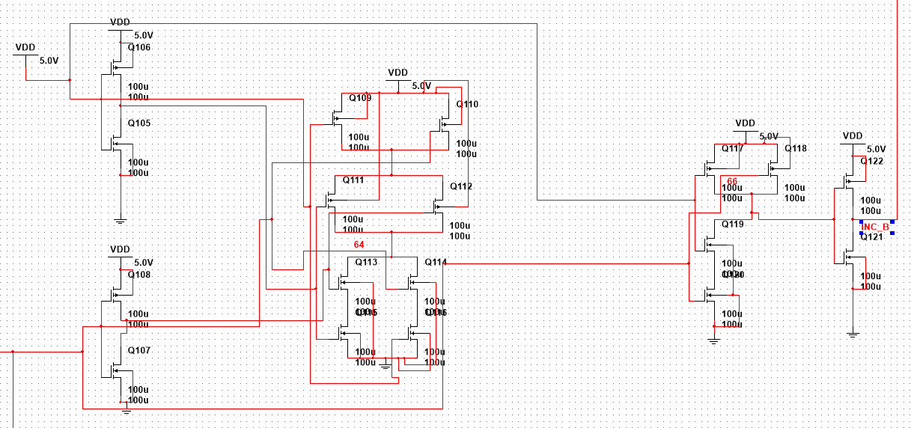
IF INPUT_B=1, CARRY =5V(LOGIC 1)
THEN OUR DESERVED OUTPUT IS 10 (2)
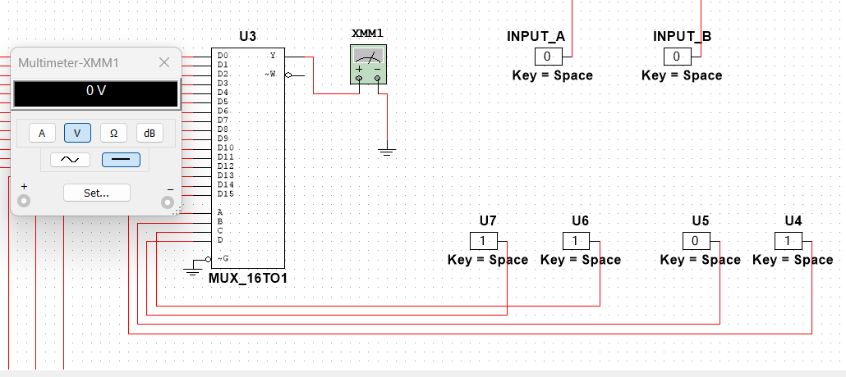
IF INPUT_B=0 ,CARRY =0V(LOGIC 0)
THEN OUR DESERVED OUTPUT IS 1 (1)

